**PRODUCT 2**

**WEB ADDRESS:**

[**https://www.indiamart.com**](https://www.indiamart.com/)

**COMPANY NAME:**

***NONE***

**PRODUCTS NAME:**

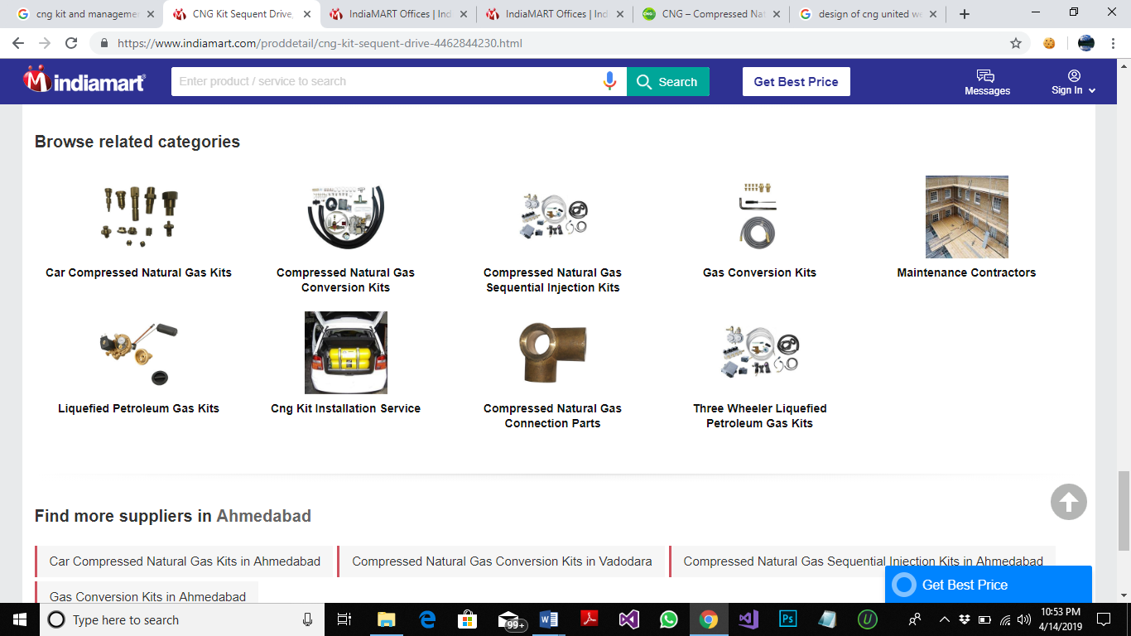

**FEATURES:**

1. SIGN IN OPTION
2. LATEST PRICE
3. DISPLAY PAYMENT METHOD, RECENT ACTIVITIES, CONTACT PROFILE IS PROVIDED.
4. SUBMIT REQUIREMENTS
5. COMPANY DETAILS AND PRODUCT DETAILS
6. SEND INQUIRY TO SUPPLIER
7. COMPLAINT,FEEDBACK AND HELP
8. TOP AND LATEST SUPPLIER DETAILS
9. SEARCH ENGINE OF PRODUCT AND SERVICES
10. FIND SUPPLIERS BY REGIONS
11. PROVIDE BUSINESS CATEGORIES DETAILS
12. BUSINESS TYPE (RETAILER ,WHOLESALER OR MANUFACTURE)

**INTERFACES:**

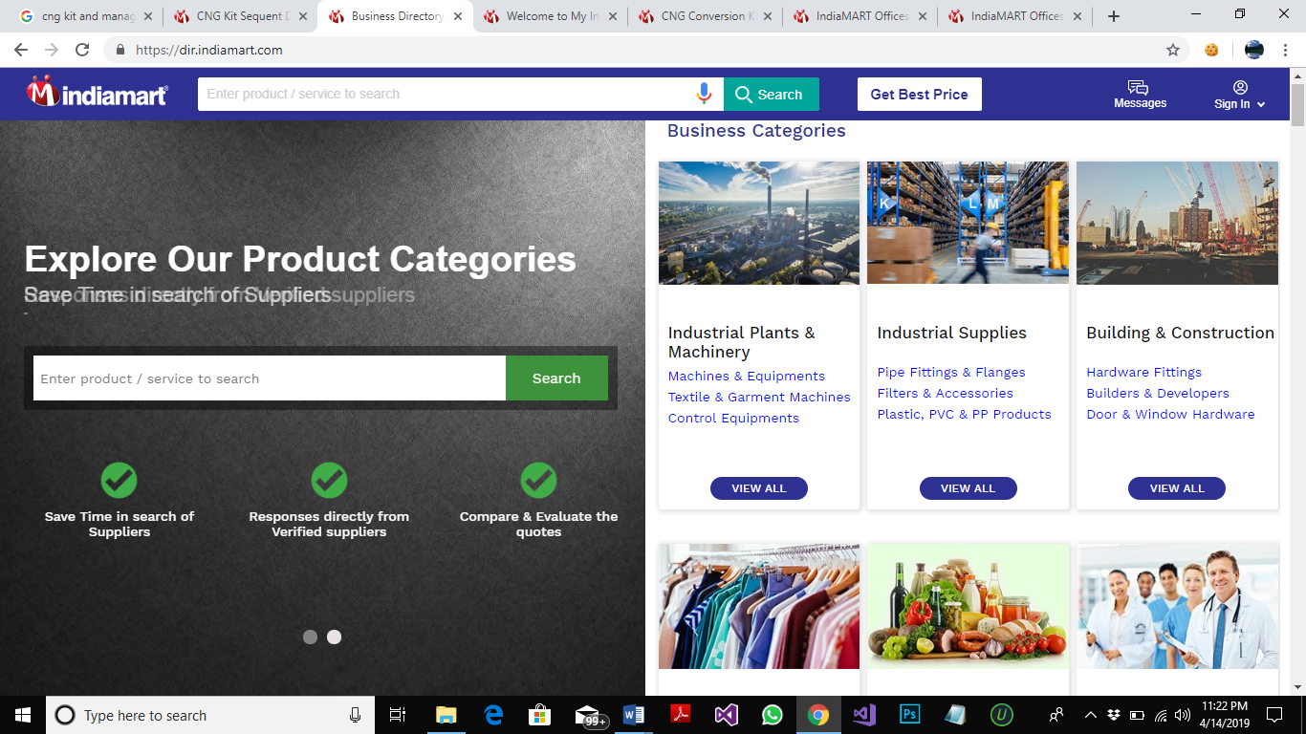

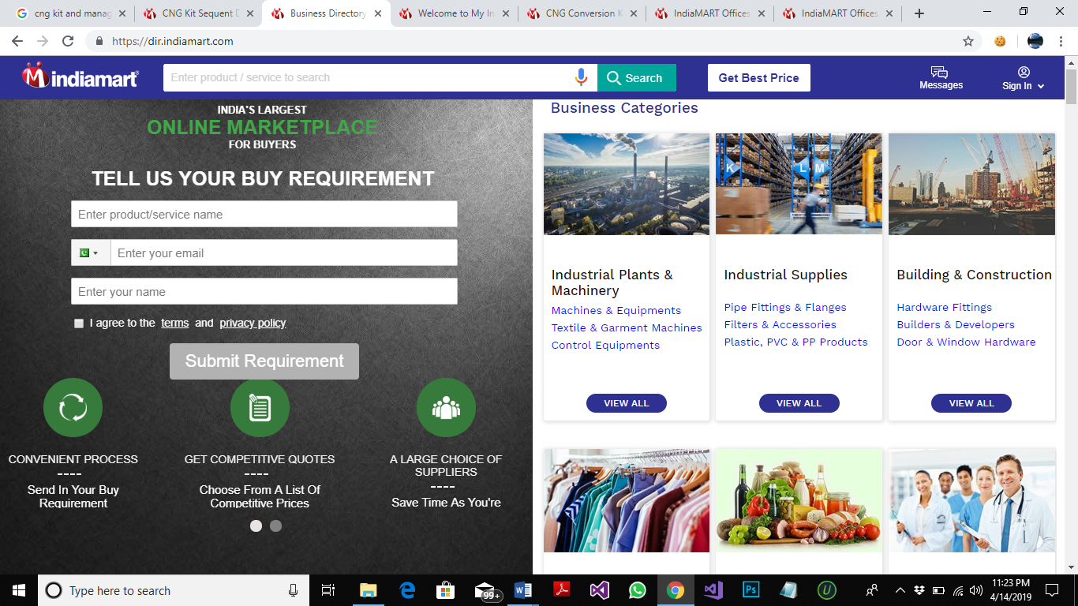 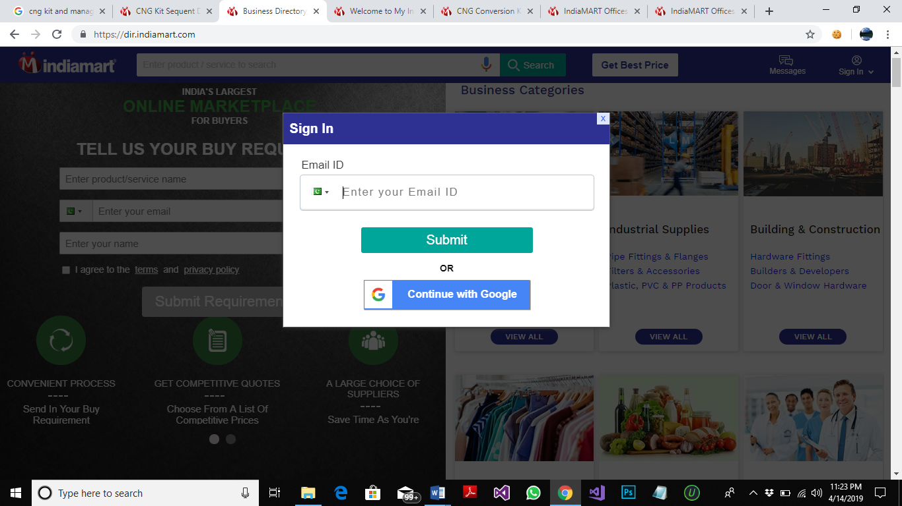 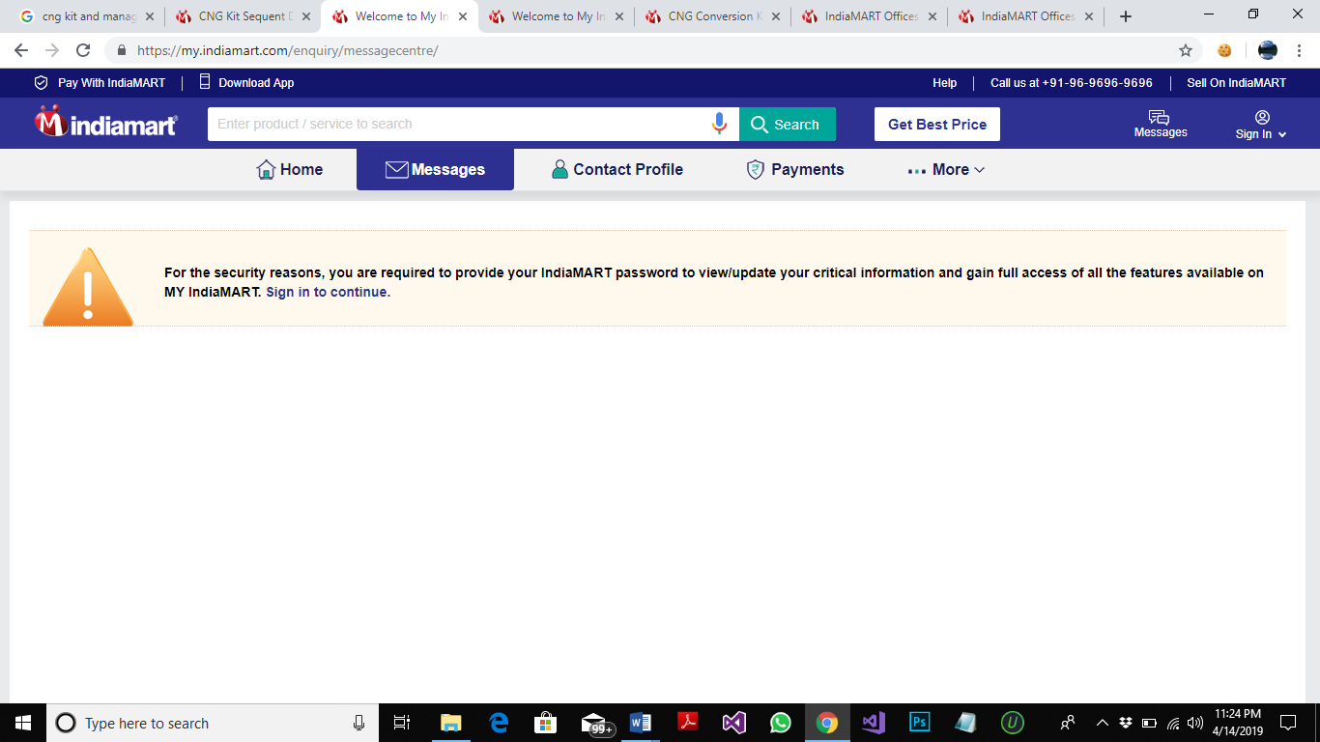 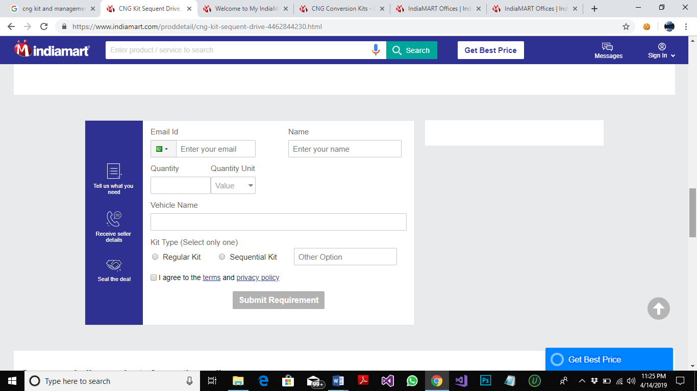 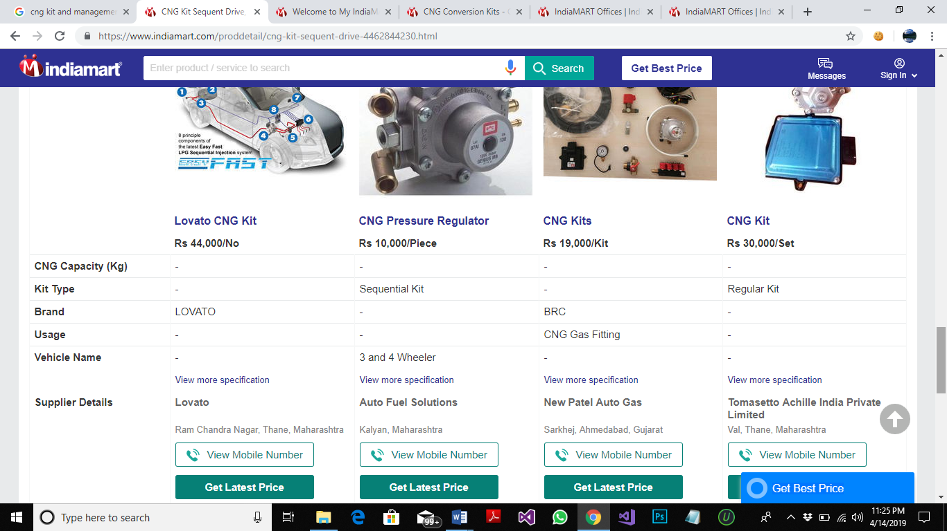 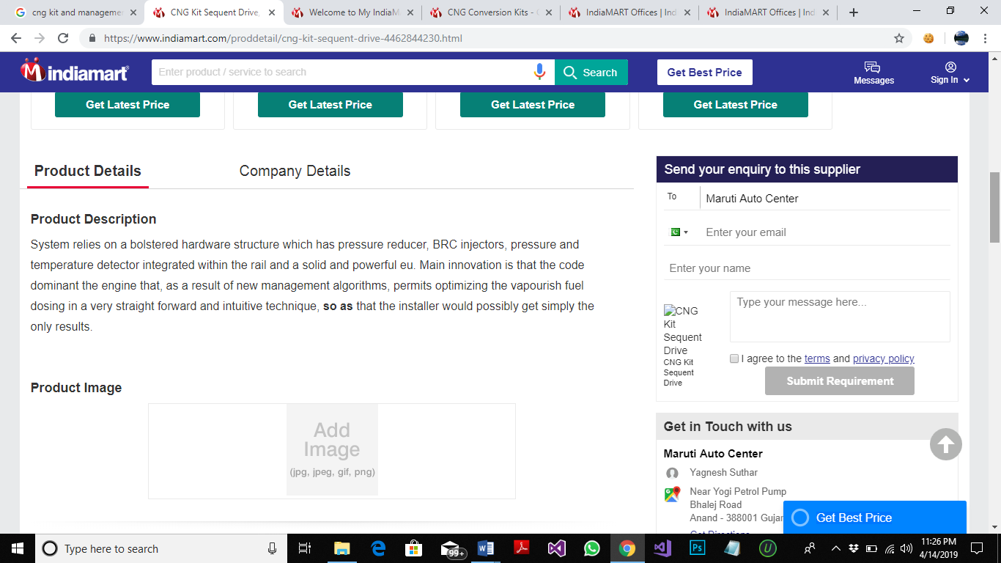

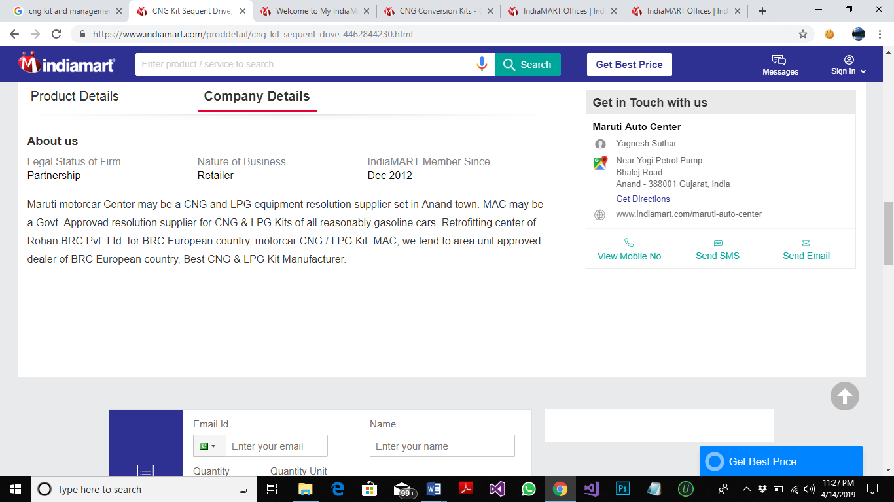 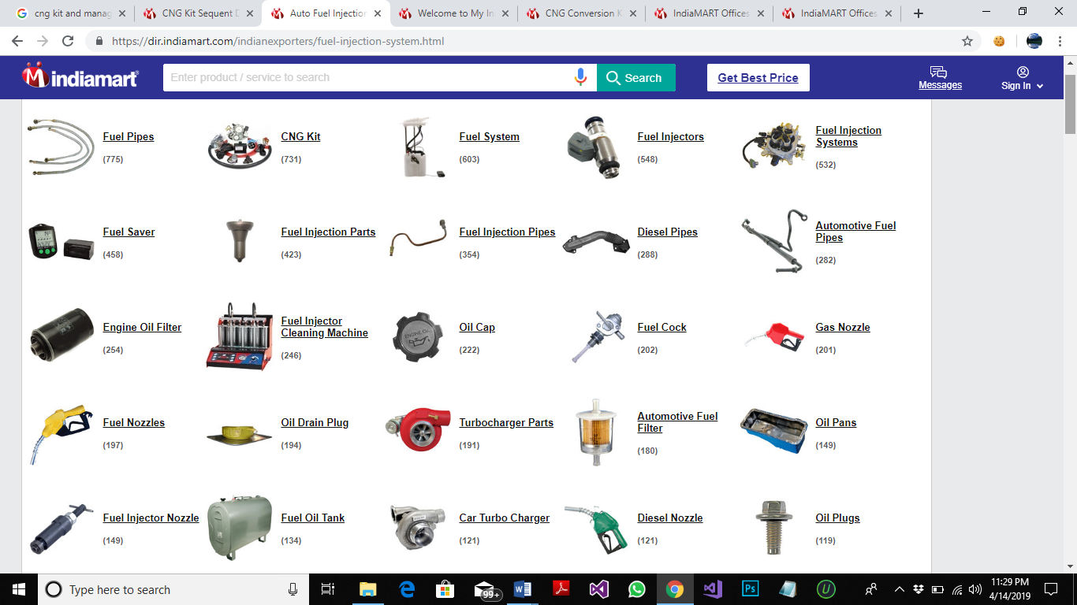 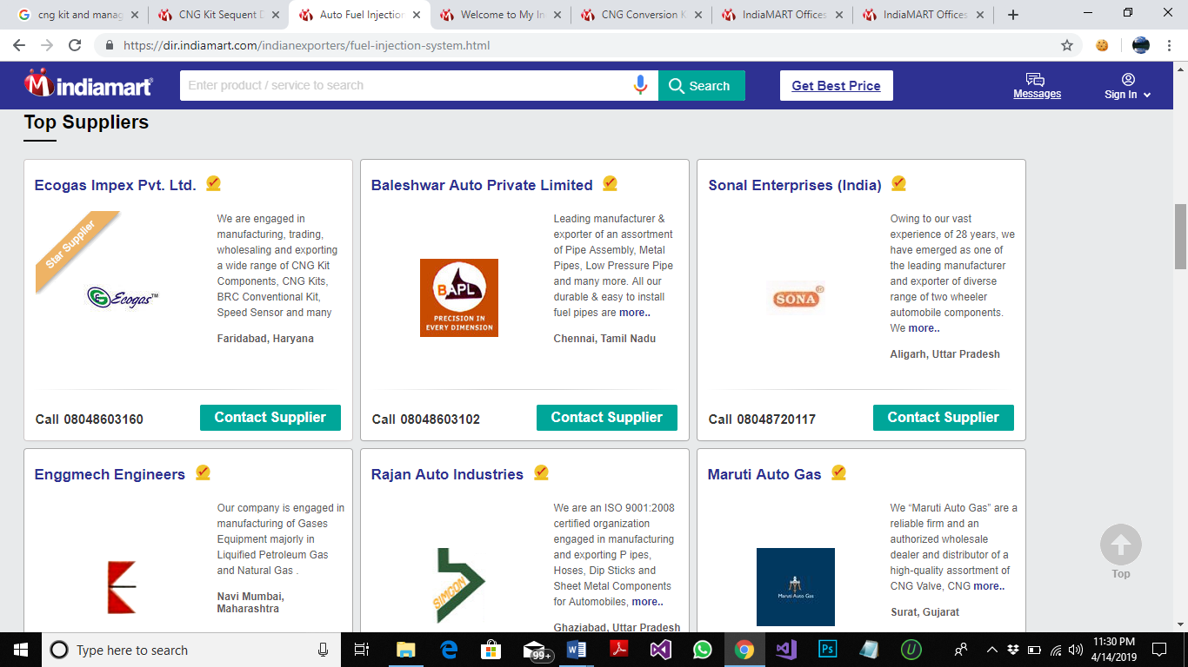

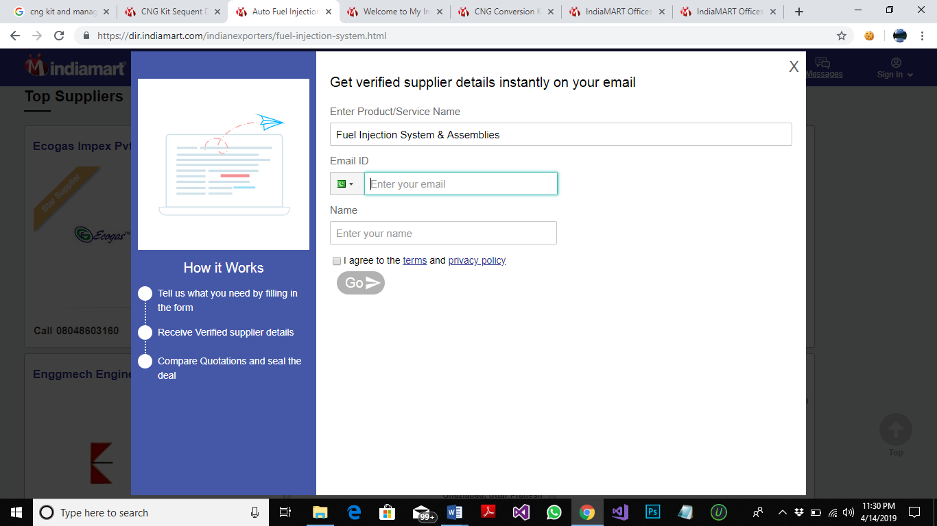 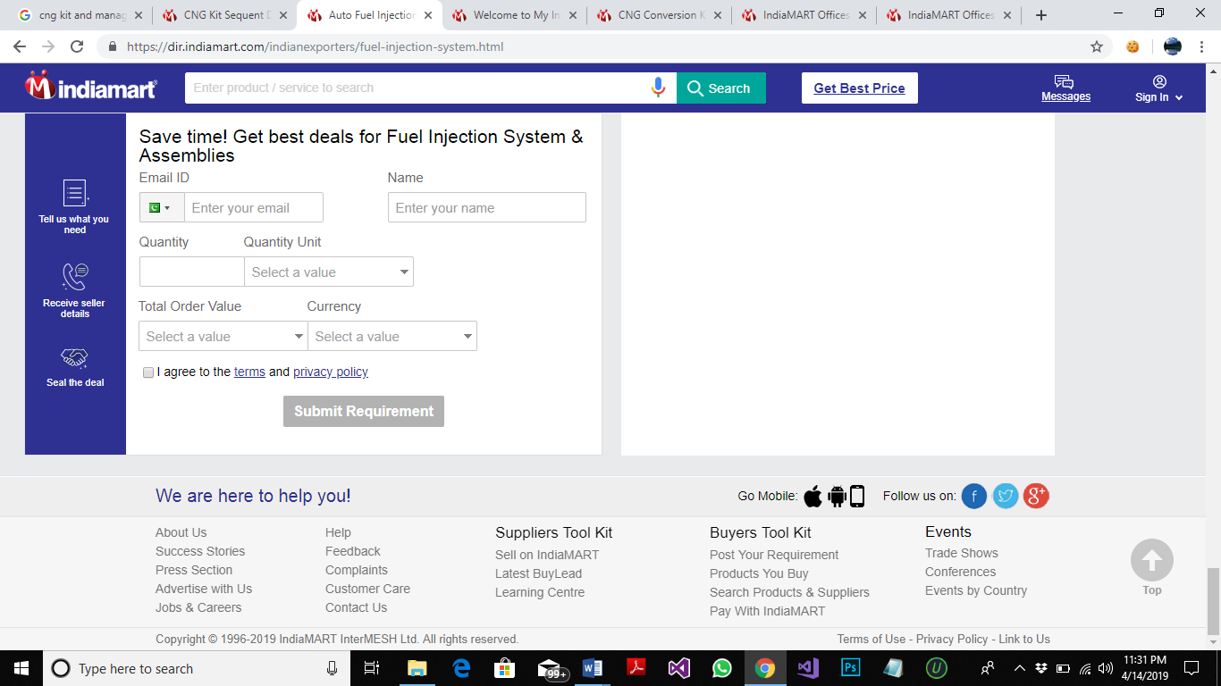 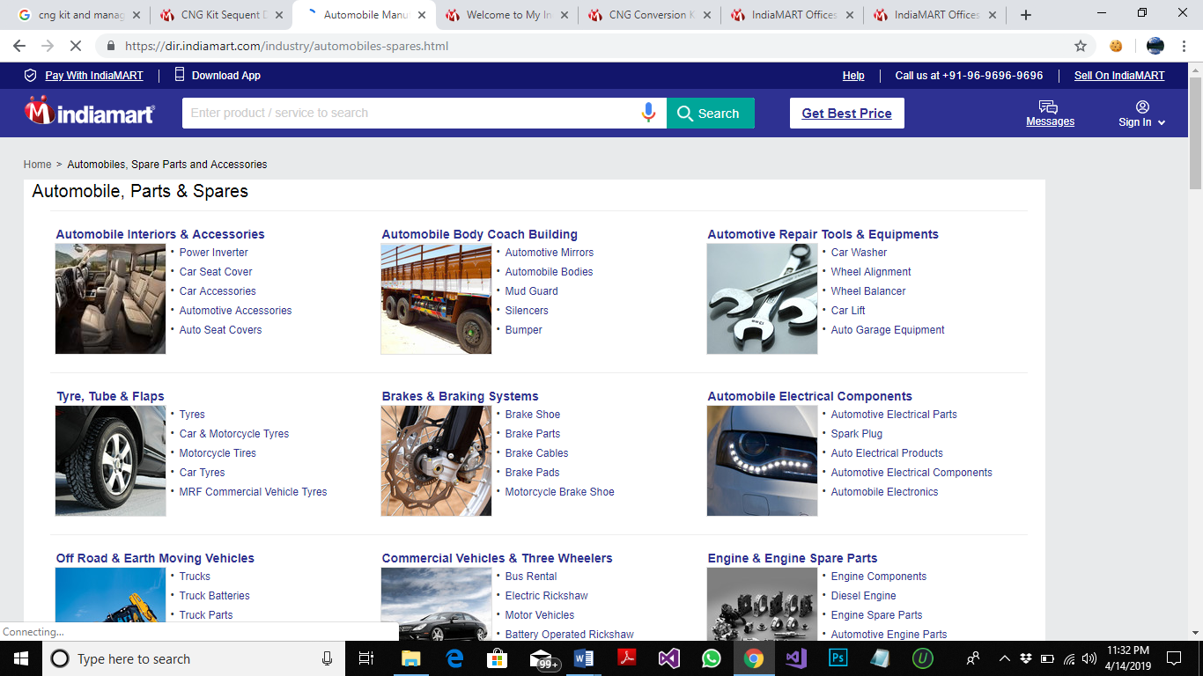

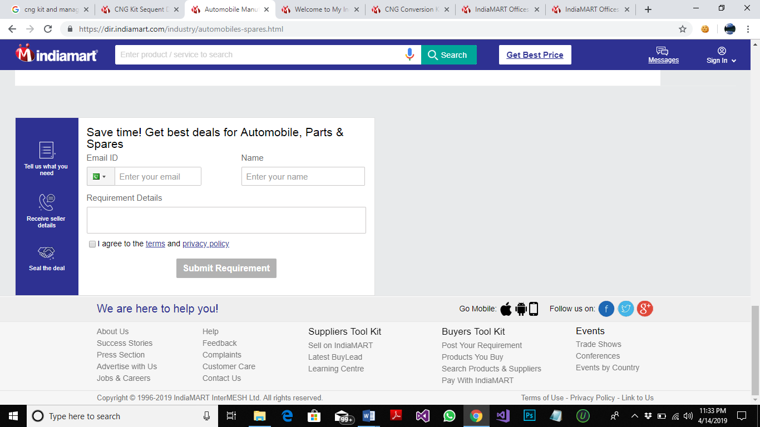 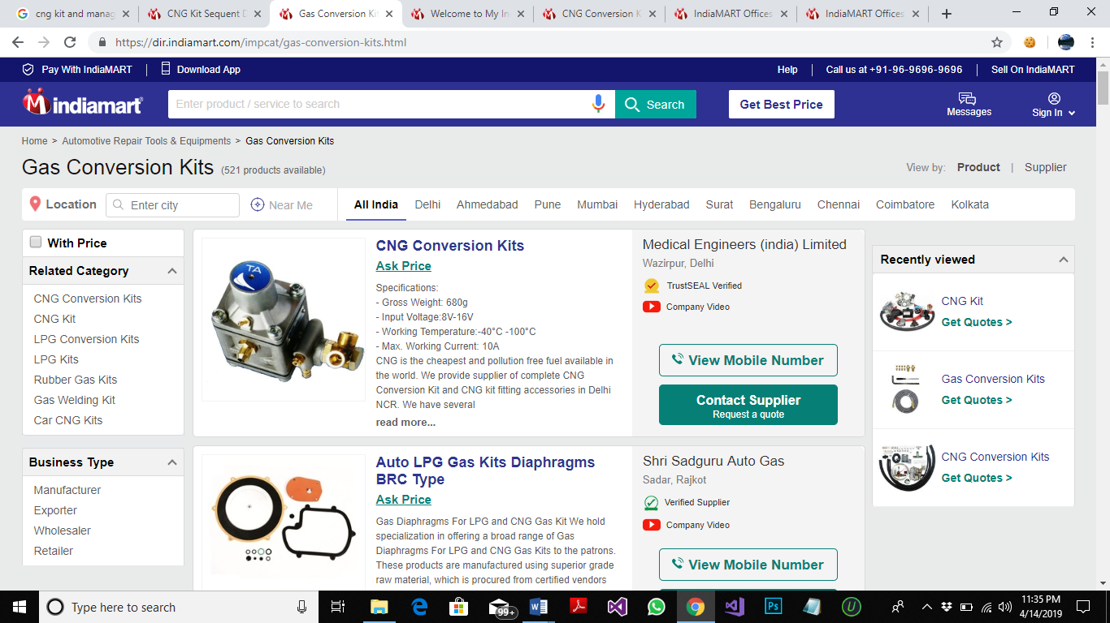

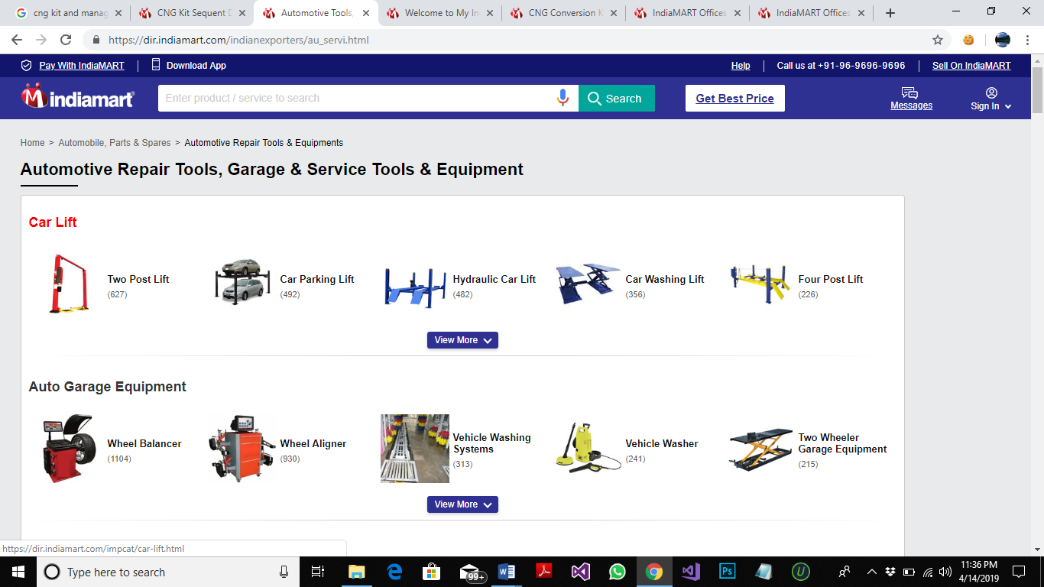 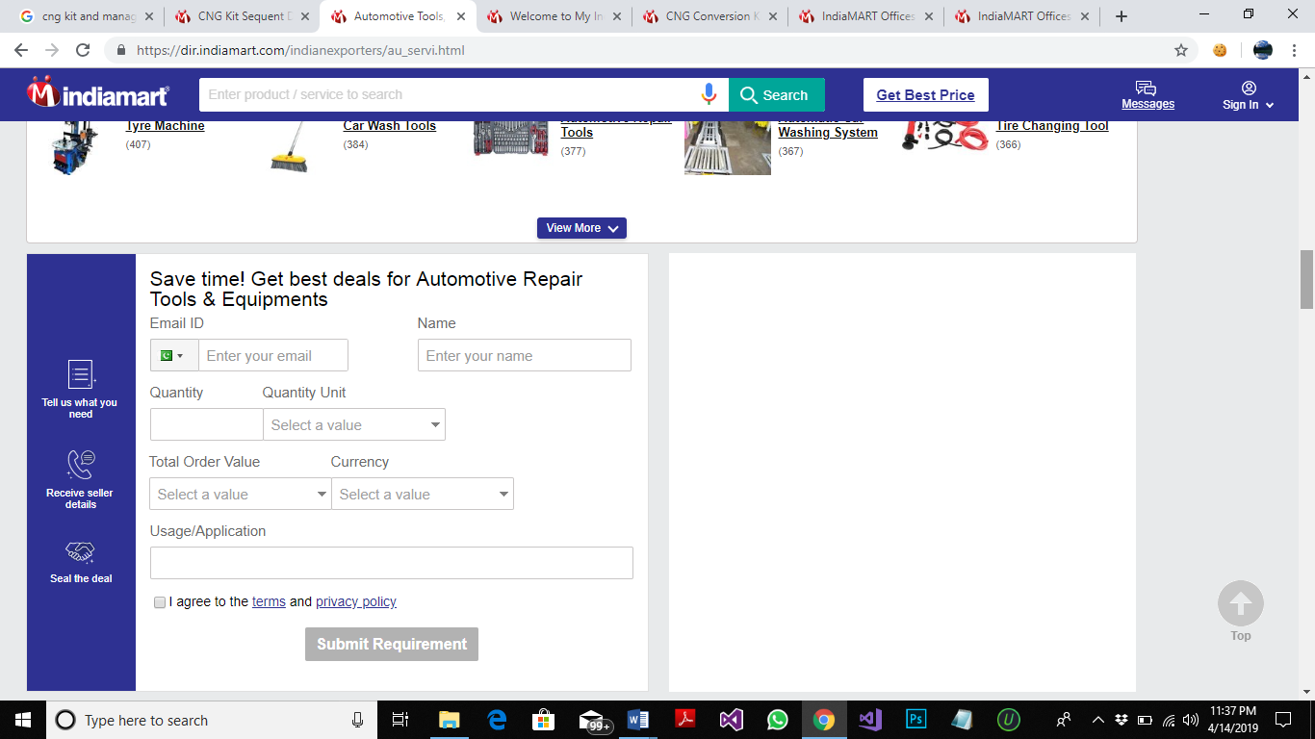 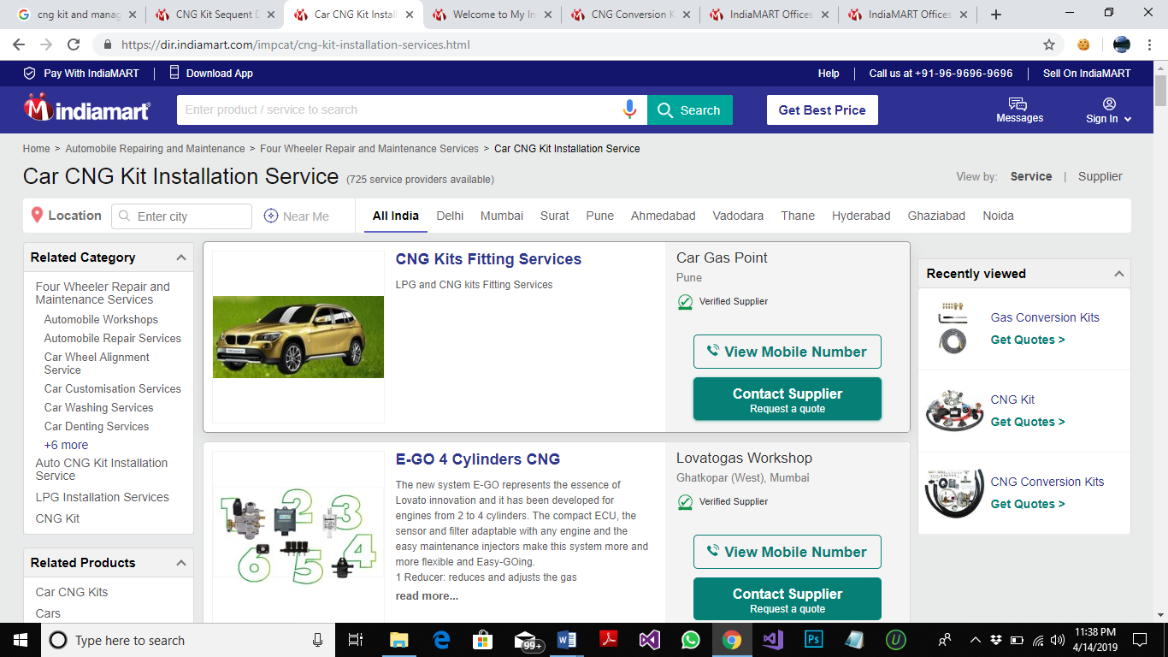

**COST:**

NOT PROVIDED

**TECHNOLOGY USED:**

ANDROID APP, IOS APP AND WEB BASE APPLICATION

**WORKFLOW:**

